**ECE0202: Embedded Systems and Interfacing**

**Lab 3: Branching, 7-Segment Displays (in assembly)**

**Due: 3/7/21 at 11:59 PM**

**Objectives**

* **Write assembly code that counts up from 0-9 in a loop**
* **Display the current number as the count is happening on a 7-segment display**
* **Include the blue button to reset the count to 0 when pressed**
* **A breadboard circuit where the Nucleo board is connected to a 7-segment display driver chip and the current number count is displayed on a 7-segment display.**

**Deliverables – total 100 points**

* **(50 points) Submission of code that is able to count upwards from 0-9 in a loop and export the current number via output GPIO pins, as well as resetting the count to 0 when the blue button is pressed on an input GPIO pin.**
* **(50 points) A Demonstration of operational circuit and program to the instructor or a TA.**
* **(10 points extra credit) Code that performs the following operation:**
  + **The blue button counts down by 2 on the 7-segment display with each click**

**Please submit your code as *.s files and your schematic as a pdf**

**Getting Started**

* This project will be written in assembly rather than in C code.
* Download the template from Canvas.
* Write the code for this lab in the “main.s” file.

**GPIO pins**

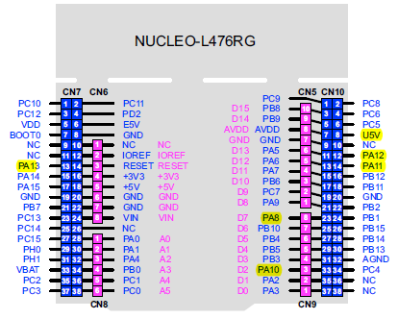

In this lab, you will need to use both input and output GPIO pins. The methods for configuring GPIO pins have been covered in the lectures and in Lab 2. The best pins to use as general-purpose output pins when interfacing with external devices are GPIOB 2, 3, 6, and 7 (circled in the diagram above).

**LS247N BCD to 7-segment display drivers**

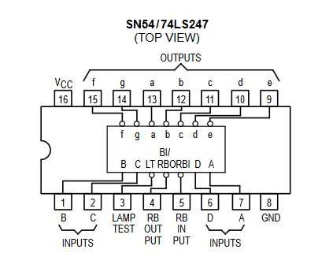

The datasheet for the LS247N chips has been posted on Canvas. Only the highlights are given here.

You have most likely derived the truth tables for converting a 4-bit BCD number into on/off states for a 7-segment display. Luckily, these truth tables have been implemented in chips and you do not have to implement this logic yourself.

Given a 4-bit BCD number (exported onto GPIO pins) where D = bit 3 (MSB), C = bit 2, B = bit 1, and A = bit 0 (LSB), the inputs to the chip are given in the overhead diagram above.

D is the Most Significant Bit (MSB) and A is the Least Significant Bit (LSB).

Pins 9-15 are open-collector (the BJT equivalent of open-drain) outputs used to sink current for the LEDs in the seven-segment display.

**7-segment displays**

A 7-segment display has 7 LEDs and is able to display the numbers 0-9 as well as some English characters (though that capability won’t be used here). A diagram of the LED layout as well as the naming system (a-g) is given below.

This 7-segment display is a common-anode device, meaning that there is a single connection to a positive voltage for all of the 7 LEDs, but they each have their own connection to a negative voltage (you must put a current limiting resistor in between each LED’s cathode and ground, or in this case, the outputs from the LS247N chip). The electrical schematics of the 7-segment display are given below. You can ignore the DP LED as we will not be using it.

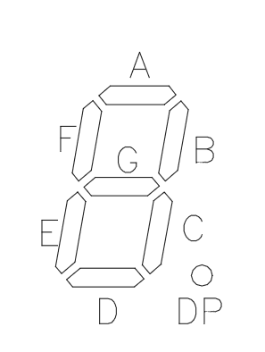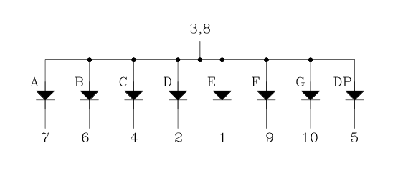

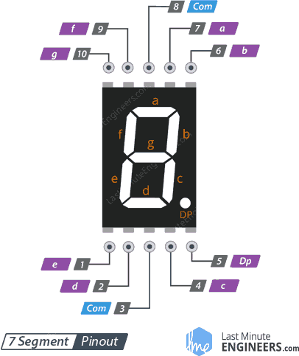

**Overall Schematic**

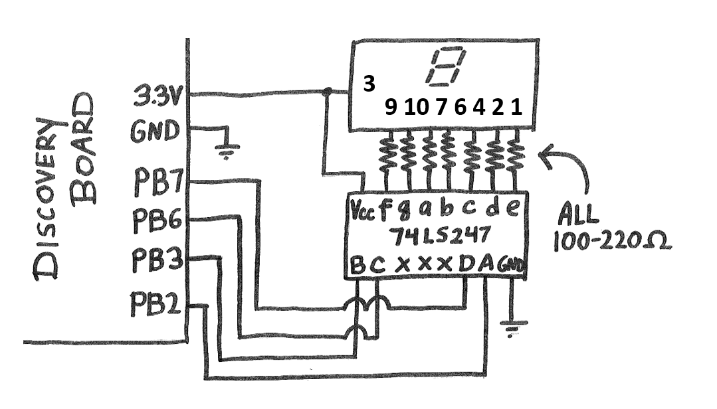

Note: devices are not to scale, and pins are not necessarily drawn in their correct locations.

**Assembly Register Declarations**

The files that you include in your project contain register memory address declarations so that you do not need to look these addresses up in the datasheet yourself. The following list gives all necessary register declarations that you will need to use in this project.

* RCC_BASE: The base address of the Reset and Clock Control (RCC) module
* RCC_AHB2ENR: The offset for the AHB2ENR register in the RCC module
* GPIOC_BASE: The base address of the GPIOC modules
* GPIOB_BASE: The base address of the GPIOB modules
* GPIO_MODER: The offset for the Mode Register (MODER) for any GPIO module
* GPIO_ODR: The offset for the Output Data Register (ODR) for any GPIO module
* GPIO_IDR: The offset for the Input Data Register (IDR) for any GPIO module